**Task 1:**

**Create a Directory with the Name Linux Practice.**

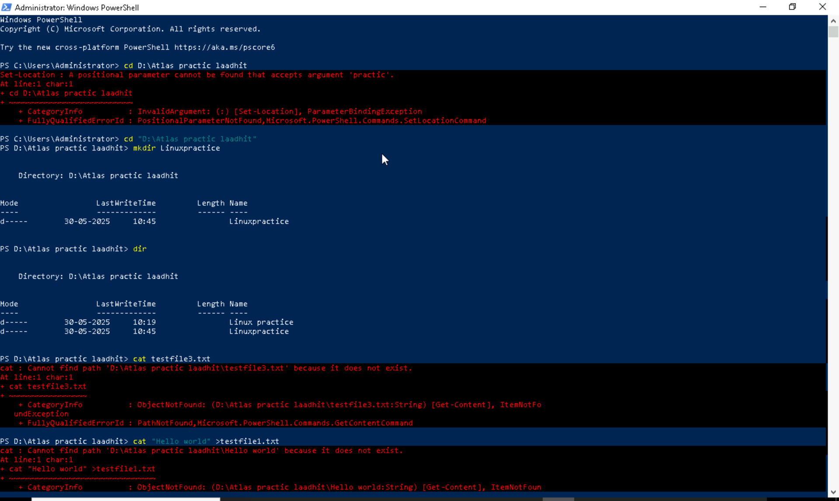

**Task2:**

**Change to the directory**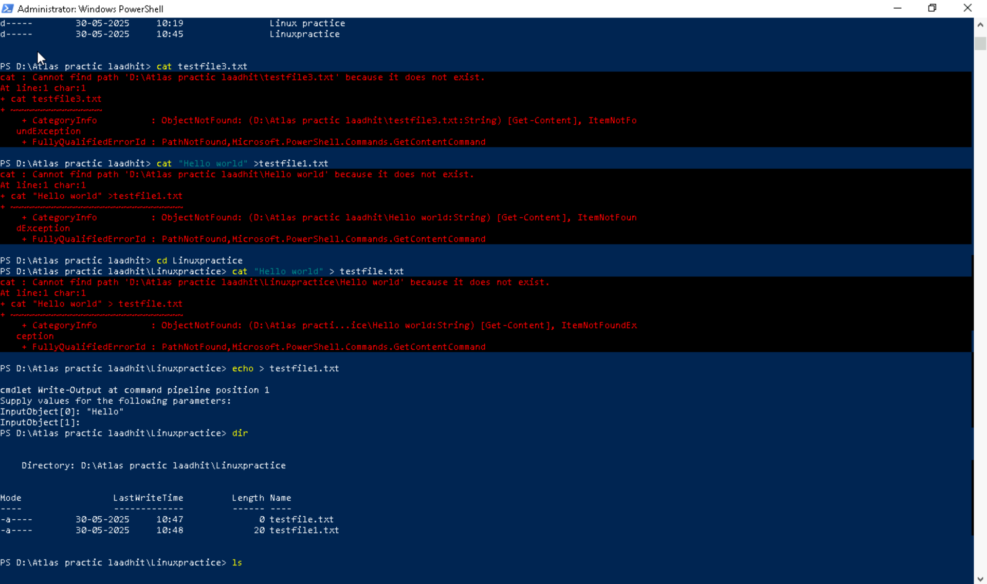

Task 3:

Create a file name TestFile1.txt and add the content to it

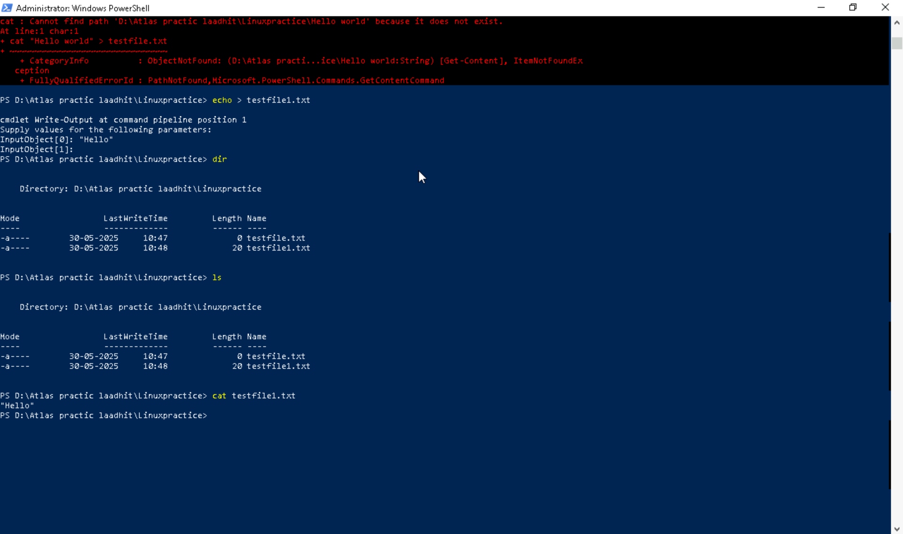

Task 4:

Create a Folder named Dummy and try to delete it.

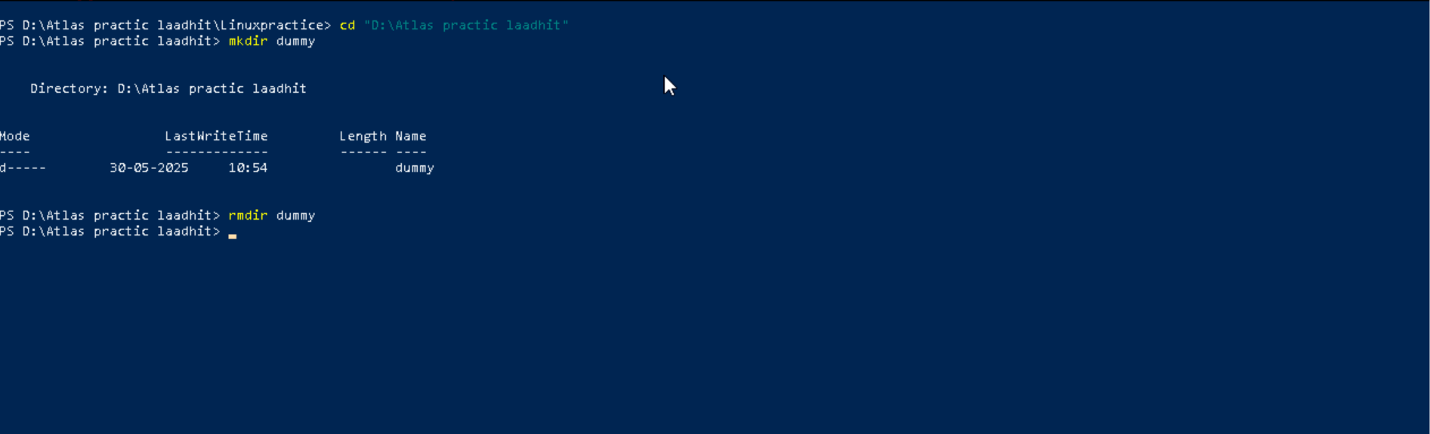

Task 5:

Plz check the working directory



Task 6:

How do you check all the files and directories in the directory you are in?

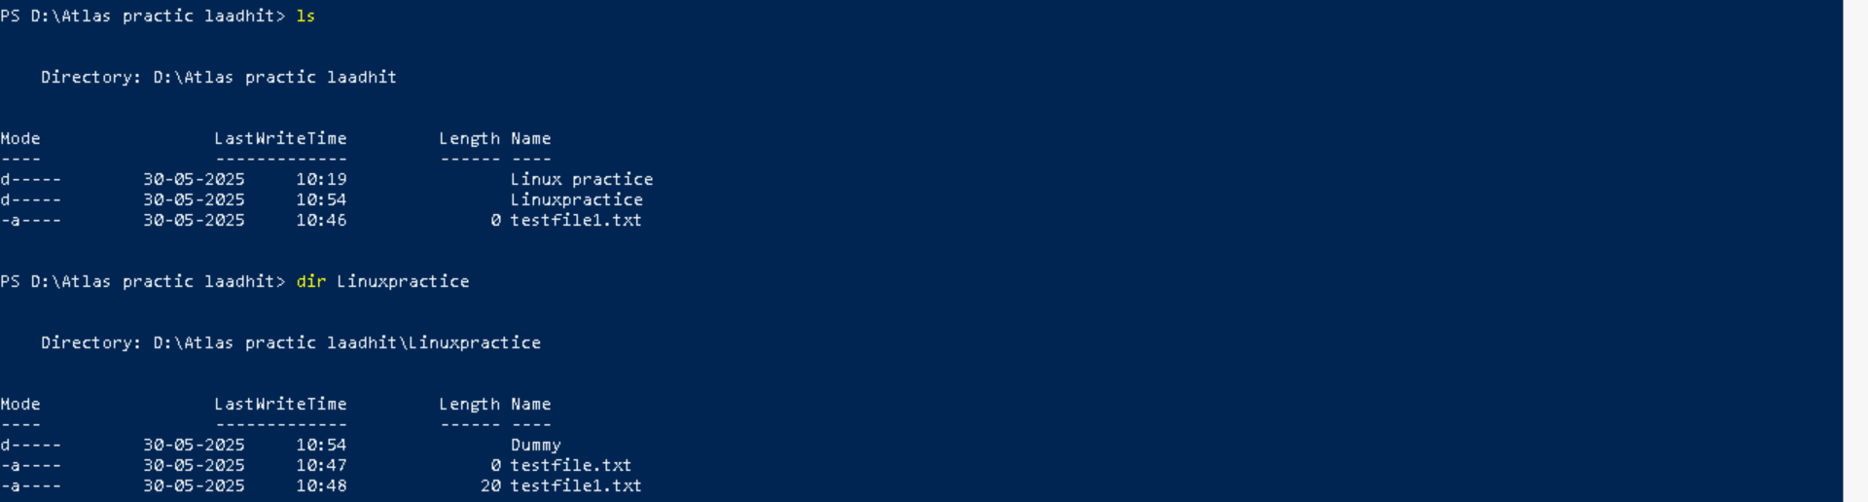

Task 7:

Create five files named TestFile2.txt.. TestFile3.txt… and so on till TestFile6.txt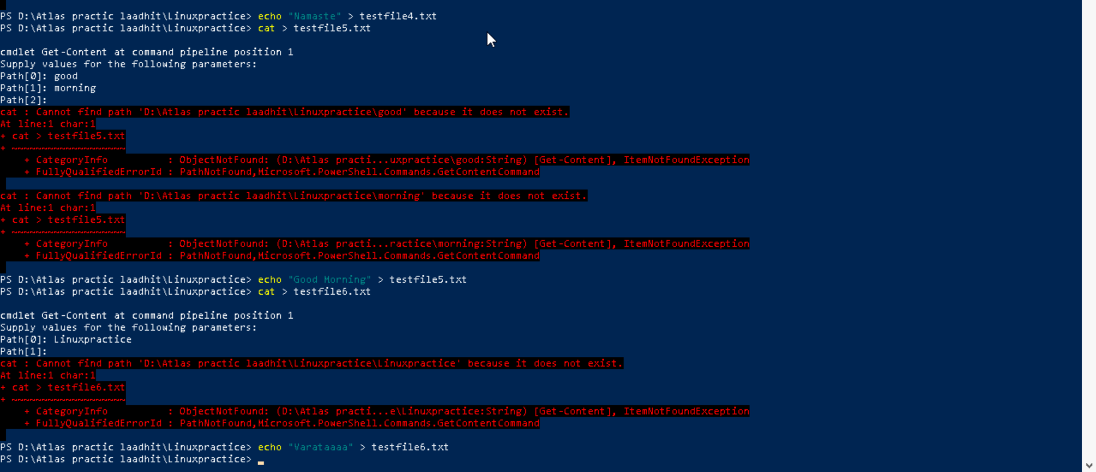

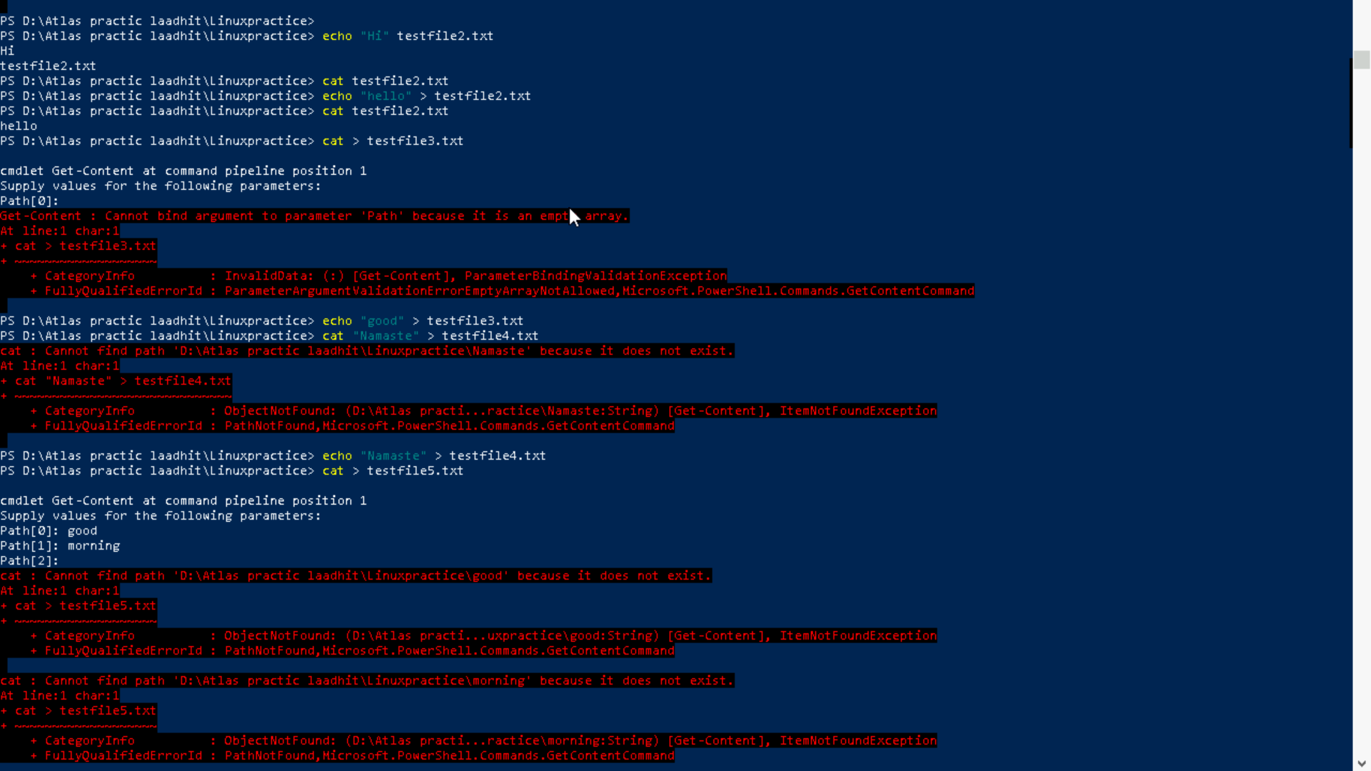

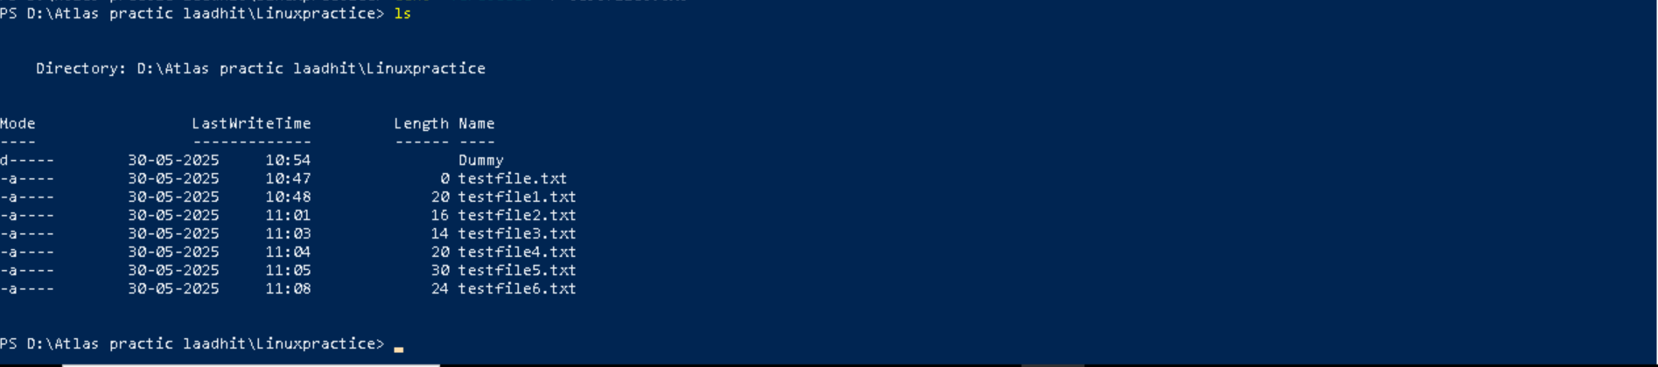

Task 8:

Copy all files from Dir 1 to Dir 2

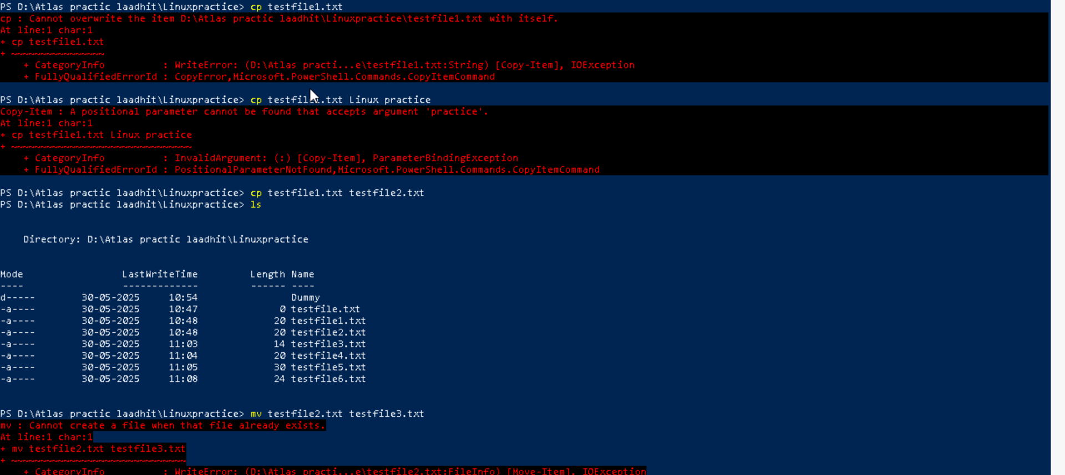

Task 9:

Move all files from Dir 2 to Dir 3

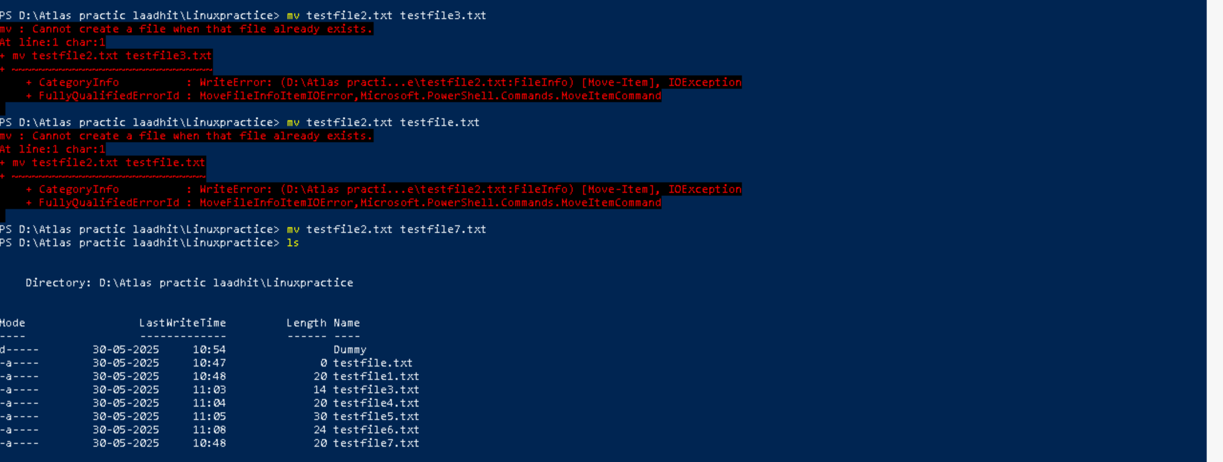

Task 10:  
Can you plz show me the diff between **rm** and **rmdir** commands with screen shots



Task 11:

Now use specifically use cat command to create a file

And add the dummy text of 2 to 3 paragraphs from the above link Lorem Ipsum.

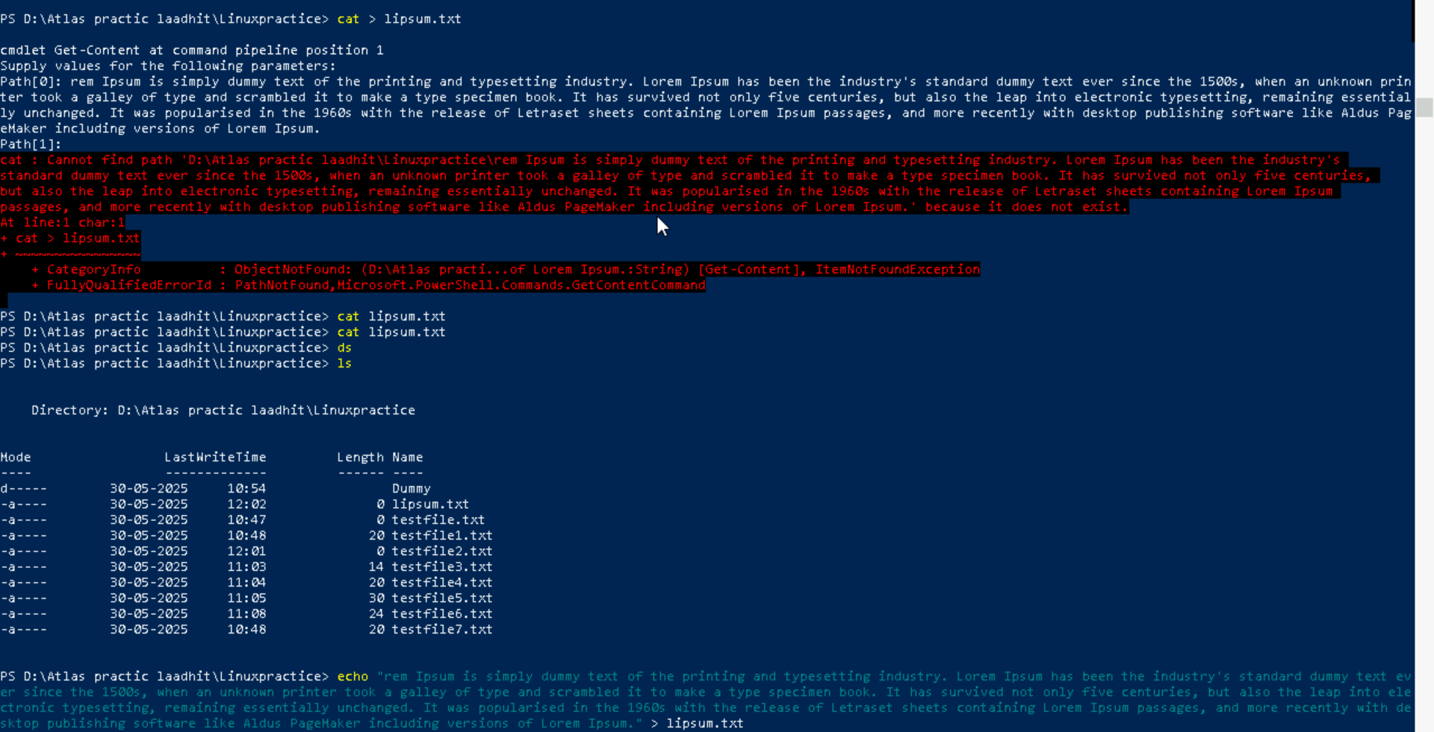

Task 12:

How to get only the top part of your file..

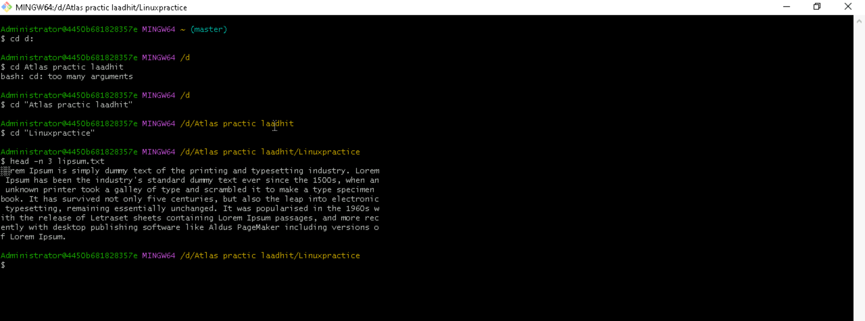

Task 13:

How to get only the last part of your file



Task 14:

Plz add dummy text of 5 to 6 pages in to the same file

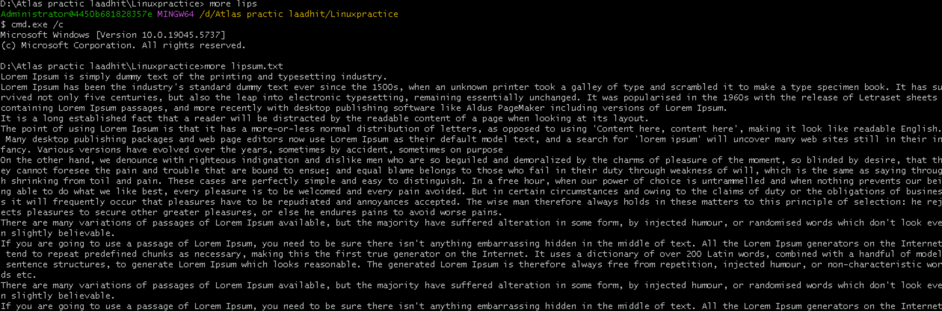

Task 16:

Can you use echo command with -e and see the diff.. Also take a ss and paste . 

Task 17:

What is diff between ls and ls -l command ..

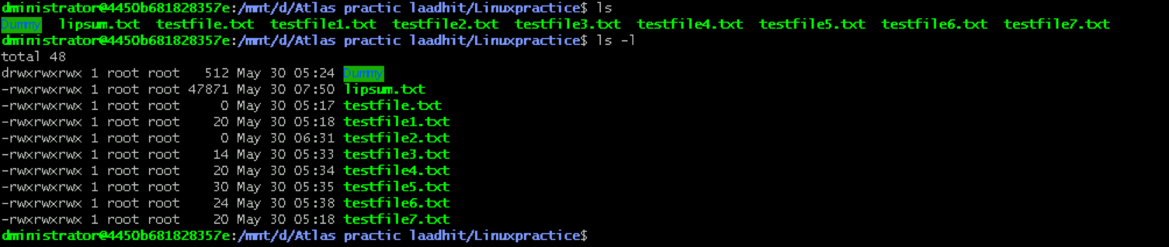

Task 18:  
Create  a file using **touch** command , **cat** command and **echo** command

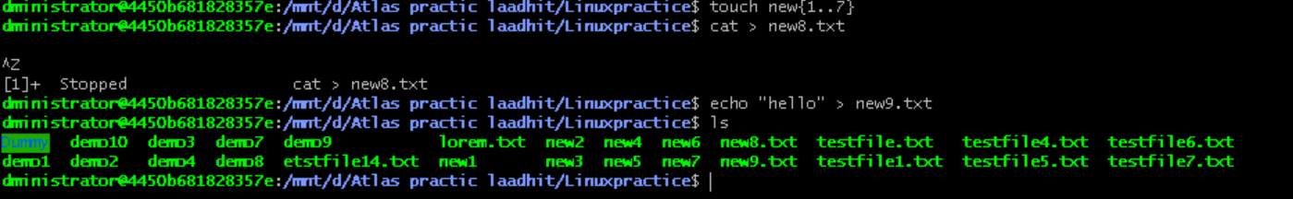

Task 19:

Can you guys try to display the calendar by using a command..

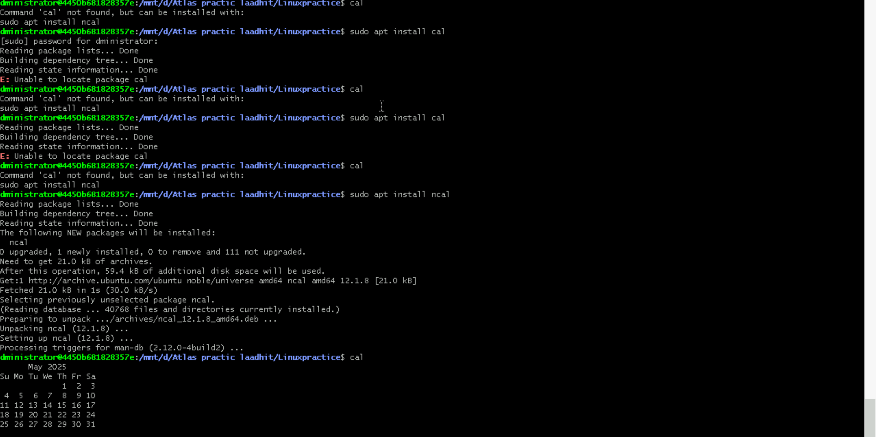

Task 20:

Can you go back to 1 directory .. at a time

Task 21:

How to know whose user u are working on ?



Task 22:

Try to find out who is peeping into your system..



Task 23:

Can you guys try to check how much disk space is consumed.

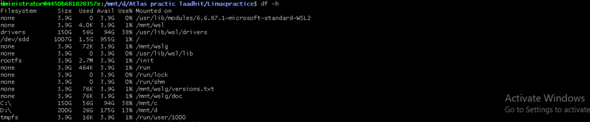

Task 24:

In the **ls -l** listing example, every file line begins with a **d**, **-**, or **l**. These characters indicate the type of the file that's listed.

Task 25:

Find the list pf all files ending with .txt

Task 26:

In Linux all the hidden files starts with . (period)

How to check all the hidden files in Linux..

Task 27:

What is the difference between . and .. in linux

Line 1 line for each

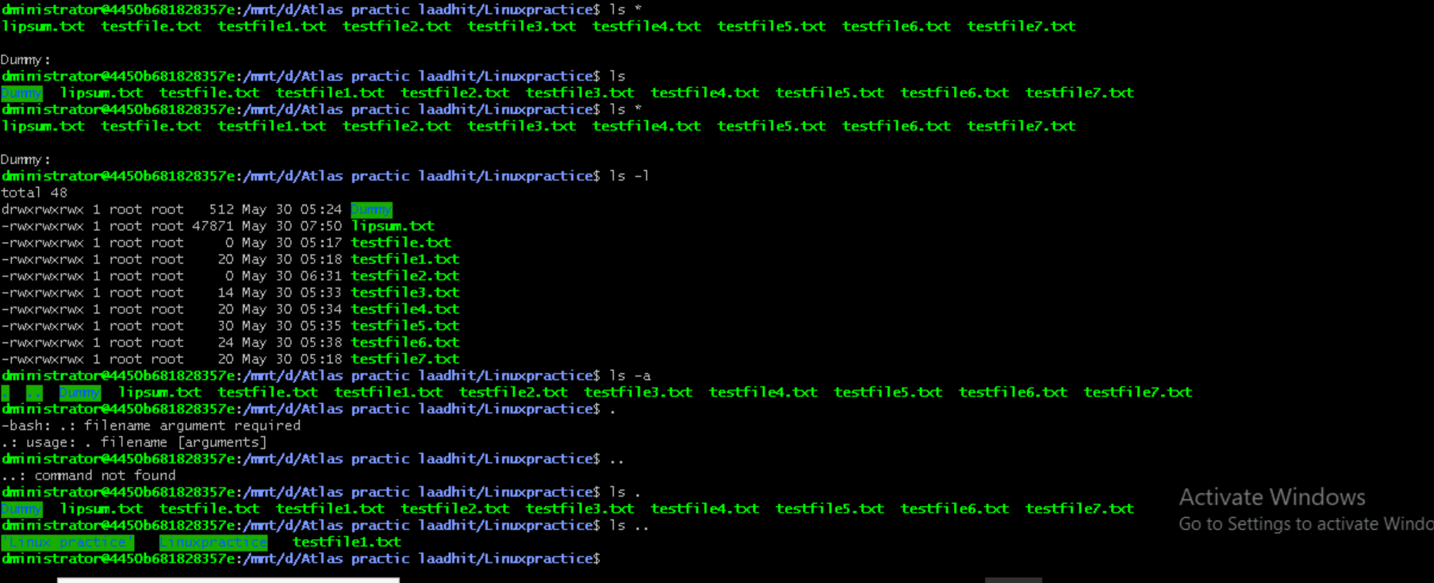

Task 28:

Can you create a file using vi editor and show the details in ss



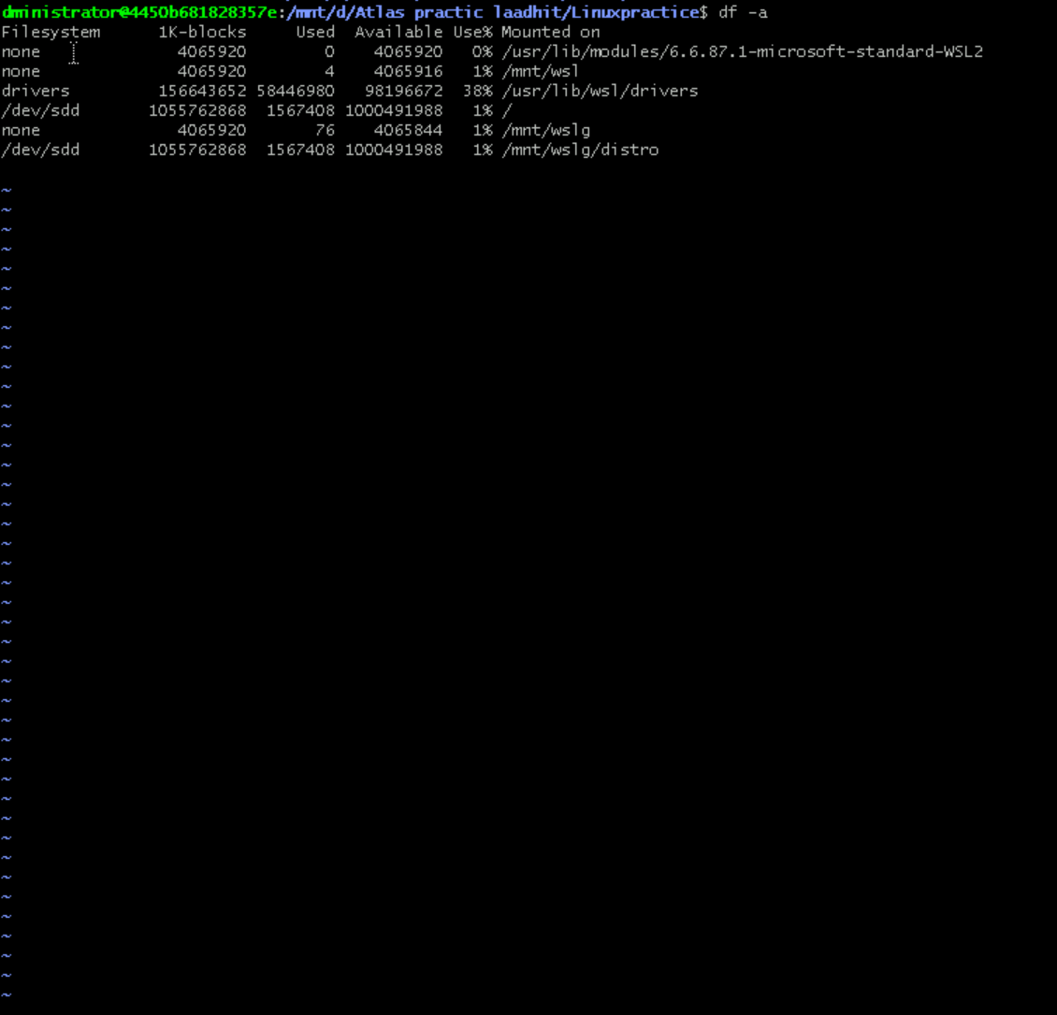

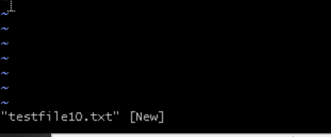

Task 29:

How to find the no of words in the file



Task 30:

What is the use of cat -b myfilename.txt command?

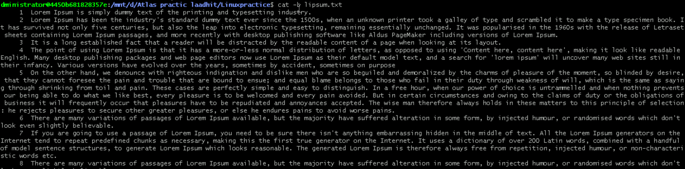

Task 31:

Can I use the wc with 2 or more files



Task 32:

How to copy content of one file to another file

Task 33:

Now I want to rename my file with MYFILENEW can i do that if so how ?

Task 34:

Can i remove or delete multiple files in linux..? How?



Task 35:

In directory / slash is root  …  can you try cd / what is it doing?



Task 36:

What is the way go go to home directory

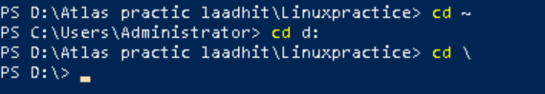

Adhoc task:

Touch command to create multiple tasks.

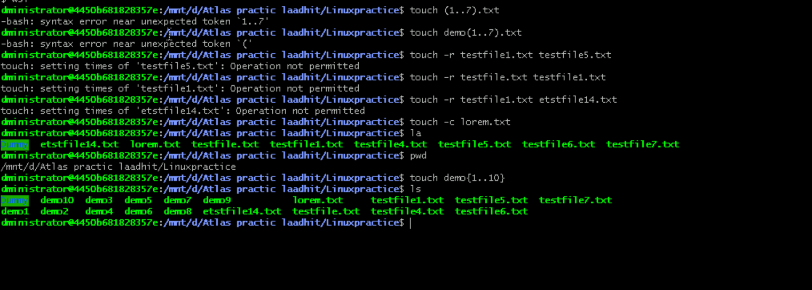

Cat /etc/passwd:

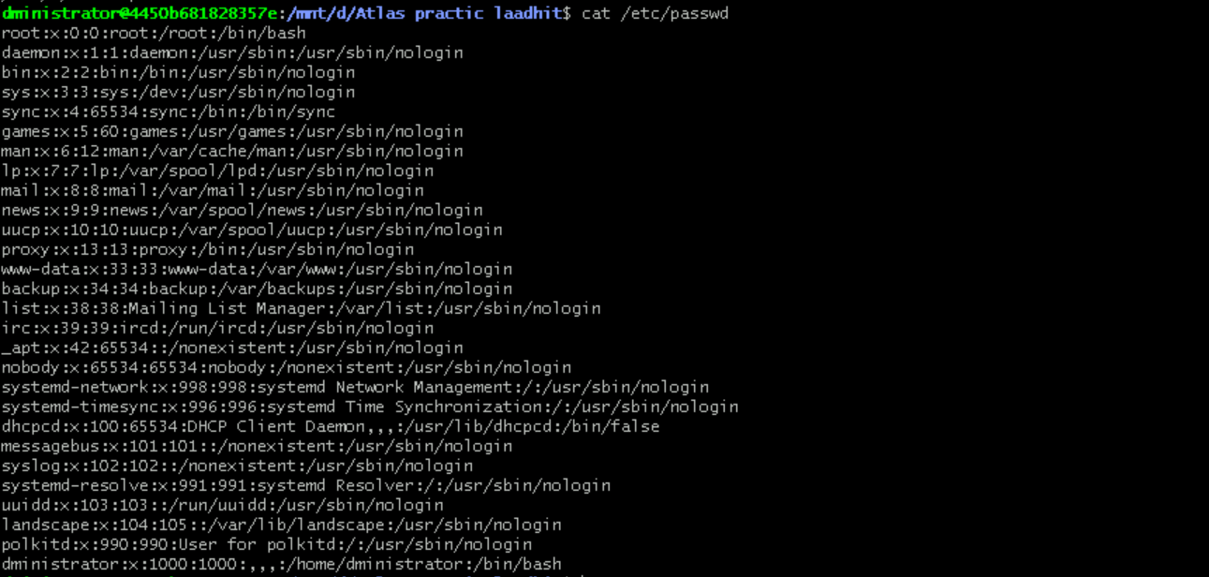

Task 37 and 38:

If i want to move to different users home directory and sudo updates. 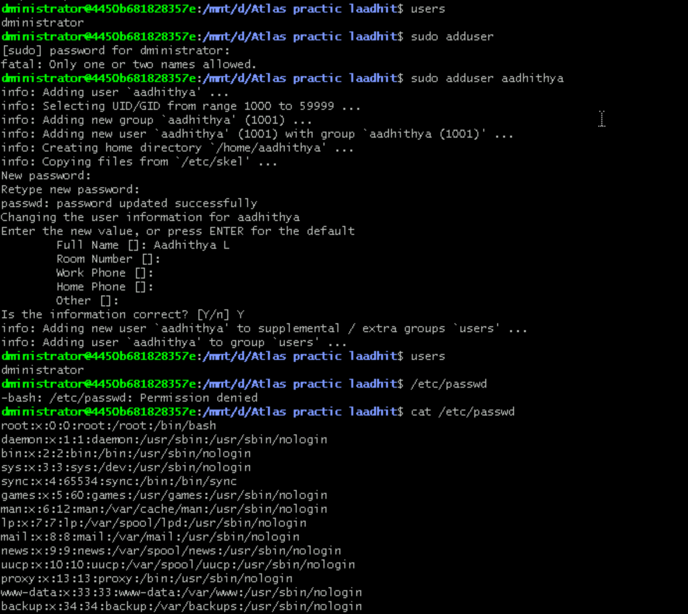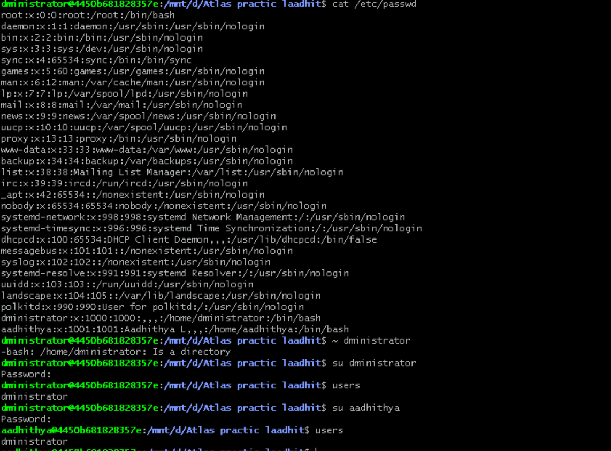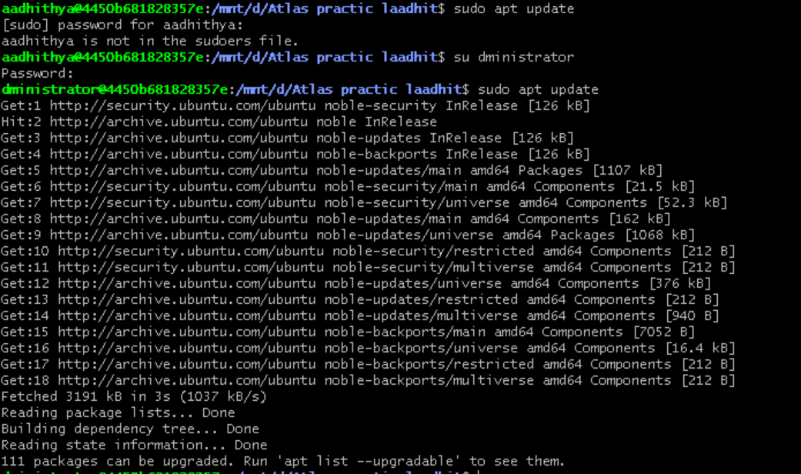

sudo apt-get install openssh-server -o Acquire::ForceIPv4=true - installing this package and establishing a ssh local host connection will give the user list

Task 38:

Chmods

Numeric Mode (Octal):   
**chmod 777 filename:** Gives full read, write, and execute permissions to the owner, group, and others.   
**chmod 755 filename:** Gives read, write, and execute to the owner, and read and execute to the group and others.   
**chmod 644 filename**: Gives read and write to the owner, and read only to the group and others.   
Symbolic Mode:  
**chmod u+x filename**: Adds execute permission to the owner.   
**chmod g-w filename:** Removes write permission from the group.   
**chmod o+r filename:** Adds read permission to others.

Adhoc:

**sudo apt install tree**- The tree command, when executed without any options, displays the directory structure starting from the current working directory. It shows the directories and files in a hierarchical, tree-like format, making it easy to understand the organization of the file system.

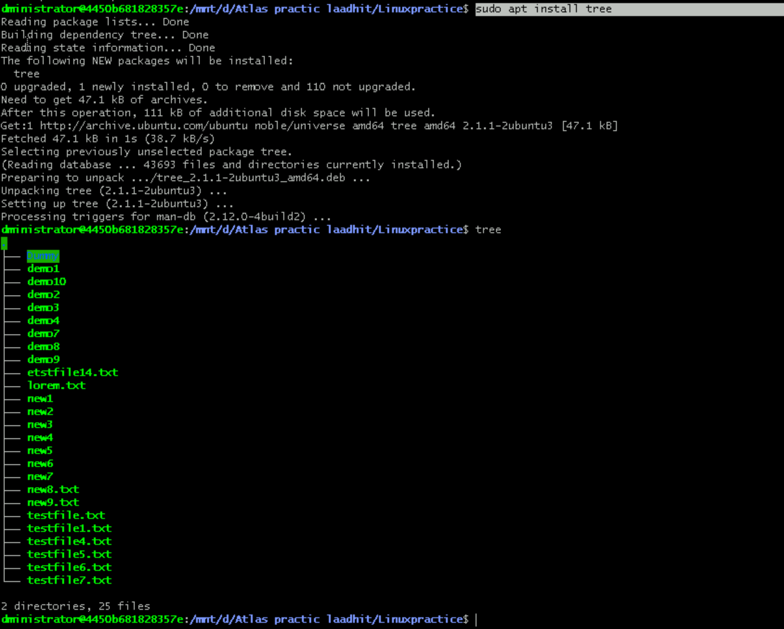

Ln- to create hard and symbolic links





